**Title Times New Roaman 14pt Bold**

S. Lee1,a, T. Tsuchiya1, K. Matsuda1, K. Nishimura1 , N. Nunomura1,

H. Toda2

*a* [*swlee@sus.u-toyama.ac.jp*](mailto:swlee@sus.u-toyama.ac.jp)

*1* *Faculty of Sustainable Design, University of Toyama, Toyama, Toyama, Japan*

*2 Faculty of Engineering, Kyushu University, Fukuoka, Fukuoka Japan*

**Keywords**: first, second, third (max 3 keywords, Times New Roman, 10 pt., flush left)

Al-Mg-Si alloys are known to constitute an Al-Mg2Si pseudo-binary system. In addition, when this alloy is solution-treated and aged, aging precipitation occurs, and the aging precipitation process is basically supersaturated solid solution → GP zone → β”phase → β'phase → β phase (Mg2Si phase) ). At this time, it is known that the equilibrium phase β-Mg2Si phase, which is inconsistent with the matrix phase, precipitates while having an azimuth relationship with the matrix phase. [1,2]

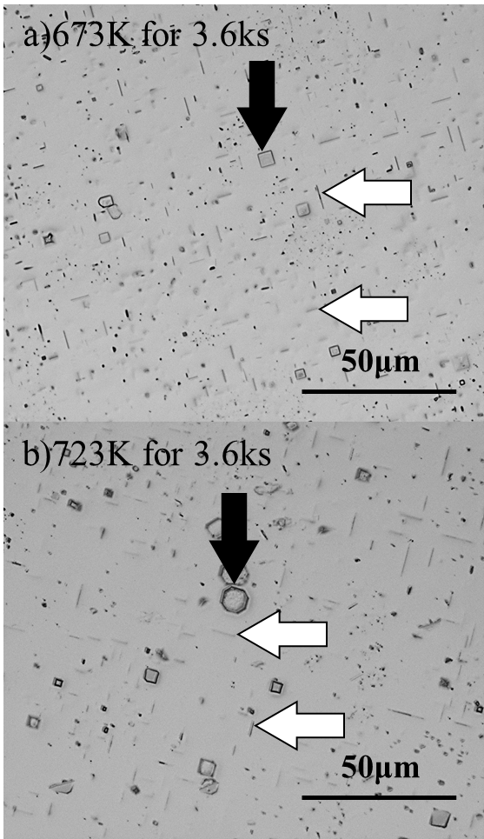

Fig. 1 Optical microscope image in Al-1.0%Mg2Si alloy aged at a)673K for 3.6ks and b)723K for 3.6ks.

Reference

[1] K. Matsuda and S. Ikeno, JILM, **53** (2003) 457–462.

*About Abstract

abstracts must be written in English

abstract must be 2 page of A4 format, all margins 2.5 cm

the font used throughout the abstract should be Times New Roman, single spacing

title: 13 pt, bold, centered

for the rest of the abstract: 10 pt

the authors list and the affiliations should be centered (please underline presenting author)

abstract may contain figures, references and acknowledgements if desired.